**INTI International College Penang School of Engineering and Technology**

**3+0 Bachelor of Science (Hons) in Computer Science, in collaboration with Coventry University, UK**

**3+0 Bachelor of Science (Hons) in Computing, in collaboration with Coventry University, UK**

**Coursework cover sheet**

**Section A - To be completed by the student**

|  |  |
| --- | --- |
| Full Name: Matthew Loh Yet Marn | |
| CU Student ID Number: P21013568 | |
| Semester: 1 | |
| Session:  **August 2022** | |
| Lecturer:  **Nadhrah Abdul Hadi (nadhrah.abdulhadi@newinti.edu.my)** | |
| Module Code and Title:  **4067CEM Software Design** | |
| Assignment No. / Title:  **Continuous Assessment** | % of Module Mark:  **50** |
| Hand out Date:  **6th September 2022** | Due Date:  **Task 1: 30 September 2022, by 11.59pm.**  **Task 2: 18 November 2022, by 11.59pm**  **Task 3: 4 November 2022, by 11.59pm.**  **Task 4: 4 November 2022, by 11.59pm.**  **Task 5: 4 November 2022, by 11.59pm.** |
| Penalties: No late work will be accepted. If you are unable to submit coursework on time due to extenuating circumstances, you may be eligible for an extension. Please consult the lecturer. | |
| Declaration: I/we the undersigned confirm that I/we have read and agree to abide by the University regulations on plagiarism and cheating and Faculty coursework policies and procedures. I/we confirm that this piece of work is my/our own. I/we consent to appropriate storage of our work for plagiarism checking.  Signature(s): ________________________ | |

**Section B - To be completed by the module leader**

|  |  |  |
| --- | --- | --- |
| Intended learning outcomes assessed by this work:  1. Understand and apply appropriate concepts, tools and techniques to each stage of the software development  2. Understand and apply design patterns to software components in developing new software  3. Demonstrate an understanding of project planning and working to agreed deadlines, along with professional, interpersonal skills and effective communication required for software production  5. Demonstrate an awareness of, and ability to apply, social, professional, legal and ethical standards as documented in relevant laws and professional codes of conduct such as that of the Malaysian National Computer Confederation. | | |
| Marking scheme | Max | Mark |
| 1. User Story Mapping 2. Setting up a GitHub Repository 3. Creating a Class diagram and design pattern selection 4. Creating a Prototype User Interface and Usability Testing 5. Discuss the ethical issue related to the software | 20  10  30  20  20 |  |
| Total | 100 |  |

Task 1 – User Story Mapping (20 marks)

Matthew Loh Yet Marn – P21013568

# 1.1 - ABSTRACT

The purpose of this study was to determine the requirements for a software application called the College Buddy System with INTI students as its targeted audience. The mission of the software is designed to help bridge gaps in communication, making it easier for students to find people and introduce themselves to befriend like-minded individuals through Find-a-Buddy, the main feature of the system. The research was conducted through a questionnaire disseminated to potential users of the software. The questionnaire results showed a considerable interest for the system together with thorough specifications for the system. Primarily, this included wanting to use the system to find people with similar interests, for the ability to communicate with others, and the ability to set up meetups. The results of the research aid in the formation of user story maps. User story maps allow us to break down the bigger picture wants of our target users into specifications for our software in the form of a product backlog. A product backlog is a prioritized list of features or tasks that need to be completed in order to finish a project. The product backlog for the College Buddy System will be created and used for reference in various other Software Design principles like sprints and progress tracking.

# 1.2 – RESULTS (EXPANDABLE)

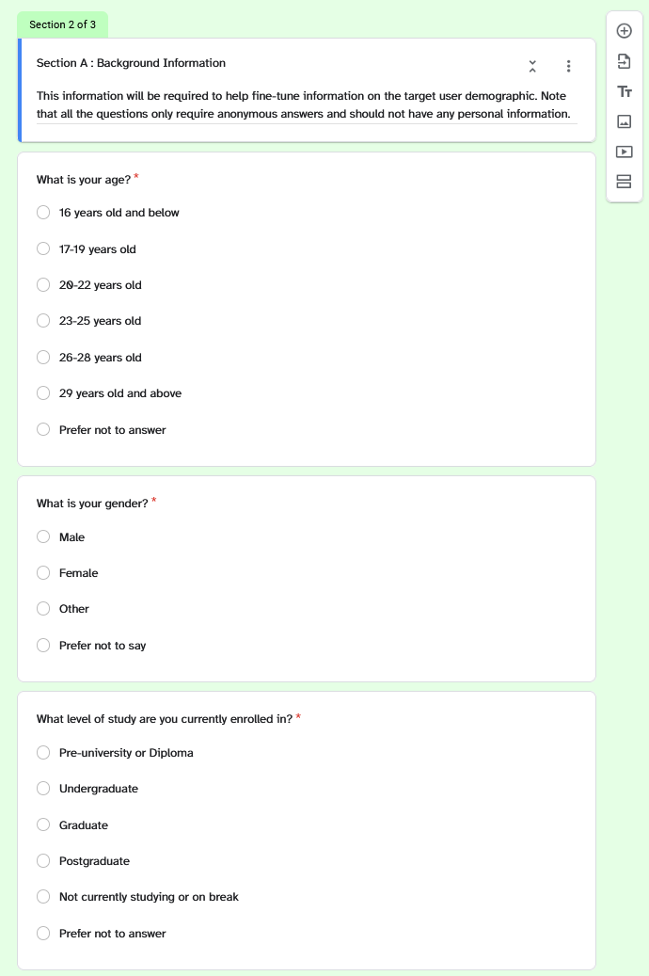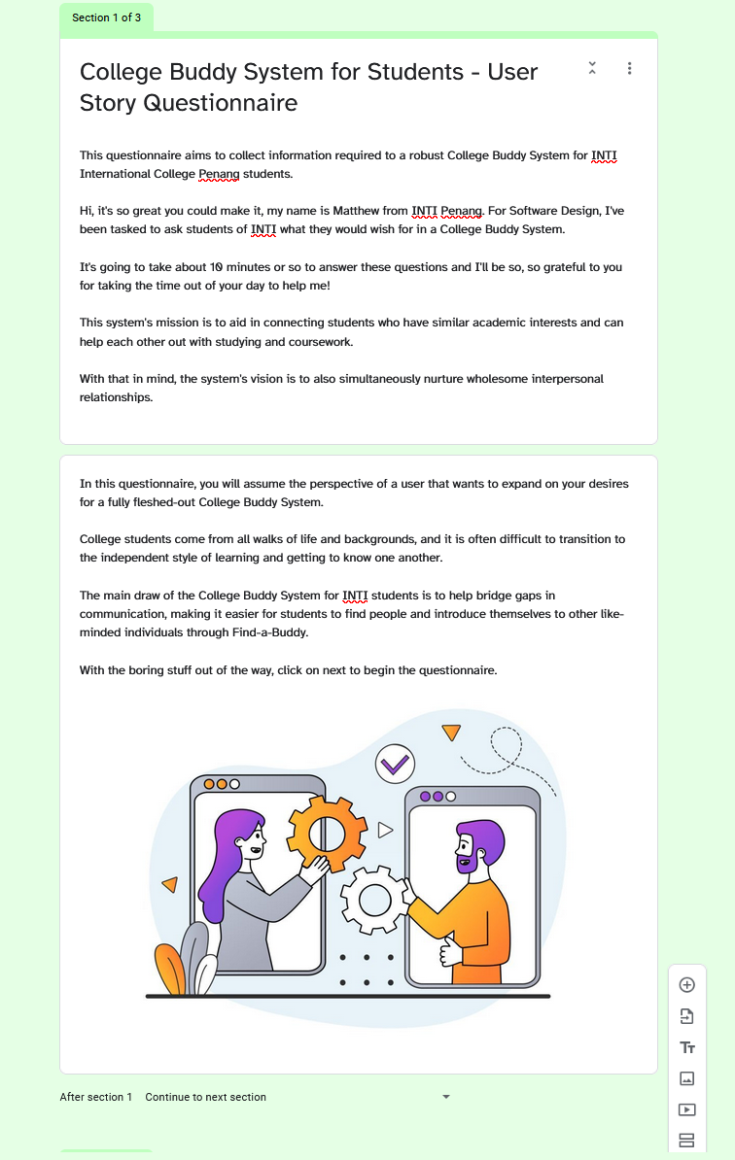

Figure 1.2.2a - Questionnaire Screenshot - Section A – Background Information (1/2)

Figure 1.2.1 - Questionnaire Screenshot - Landing Page

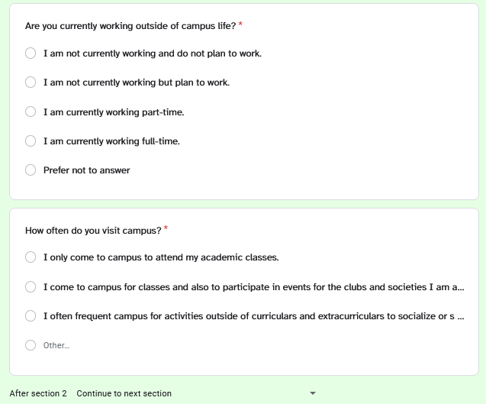

Figure 1.2.2b - Questionnaire Screenshot - Section A – Background Information (2/2)

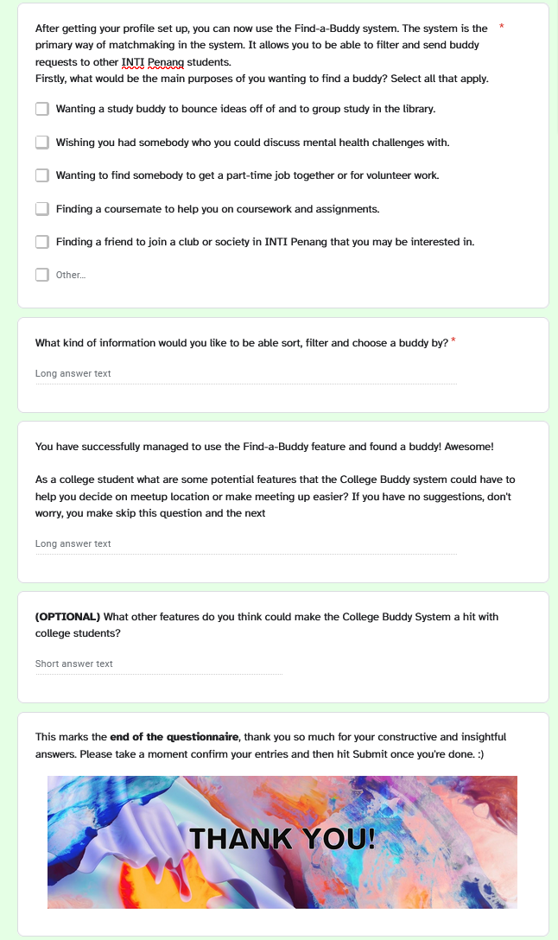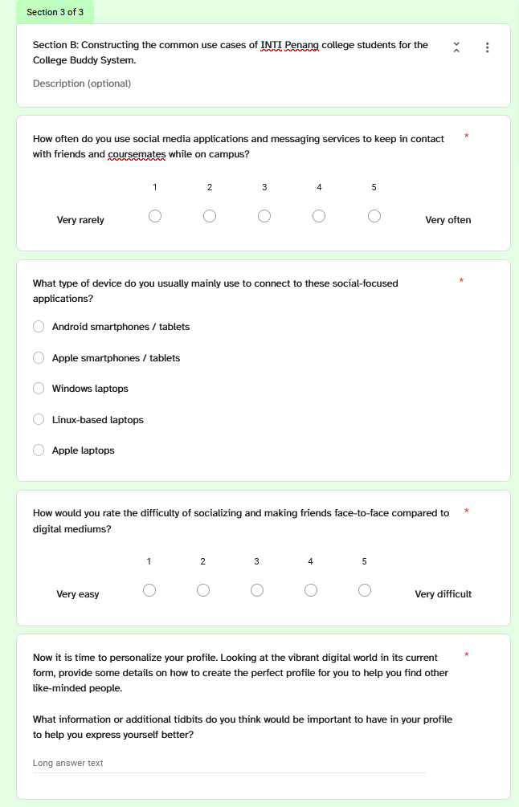

Figure 1.2.3a - Questionnaire Screenshot - Section B  
 - User Story Collection (1/2)

Figure 1.2.3b - Questionnaire Screenshot - Section B   
– User Story Collection (2/2)

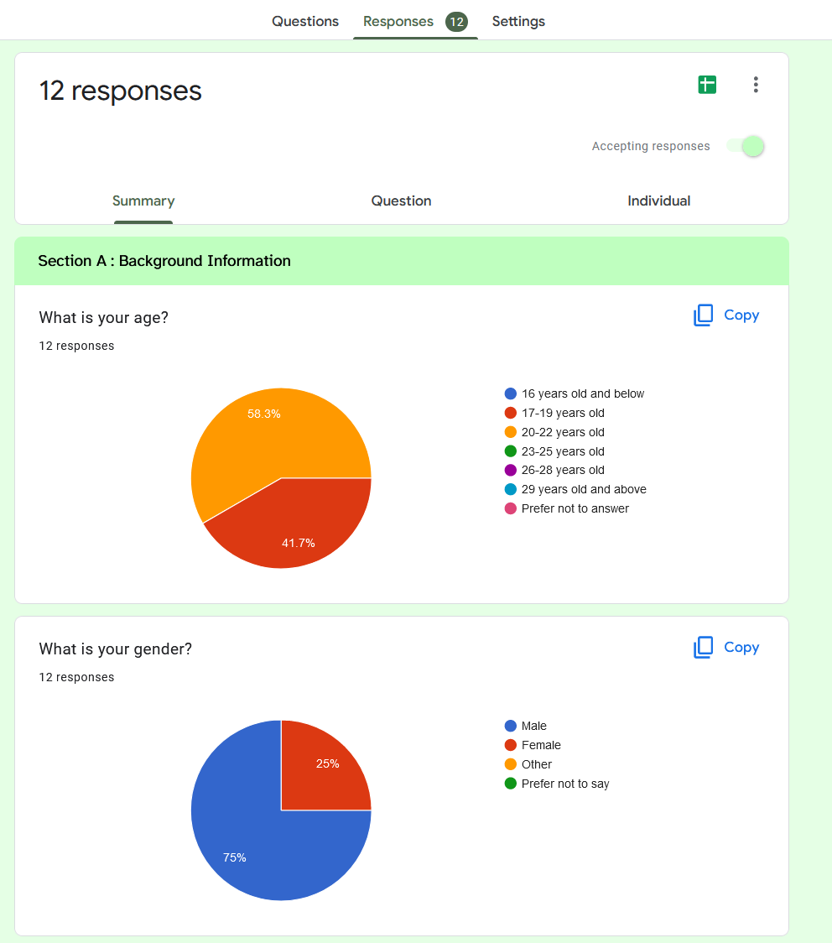

Figure 1.2.4a - Responses Screenshot - Section A (1/3)

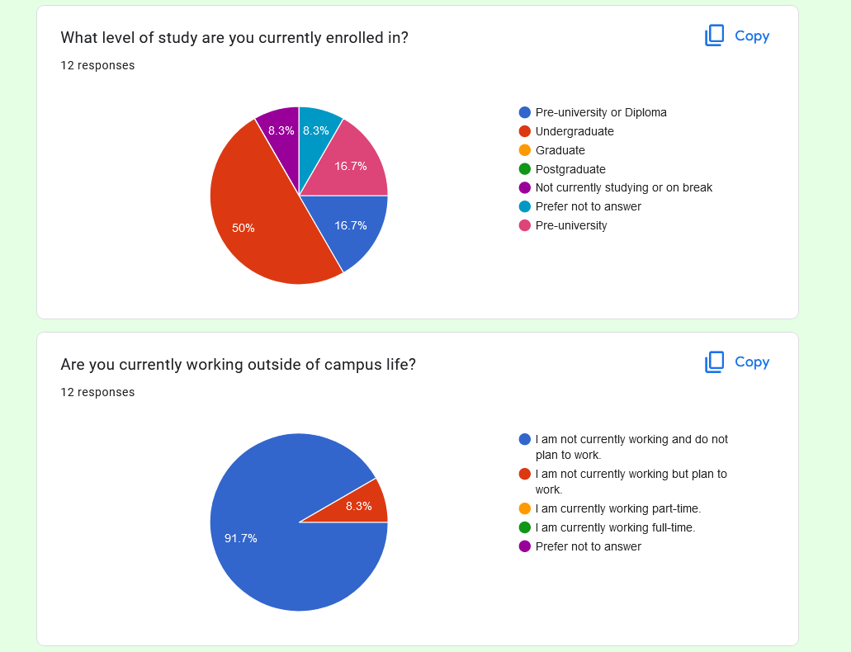

Figure 1.2.4b - Responses Screenshot - Section A (2/3)

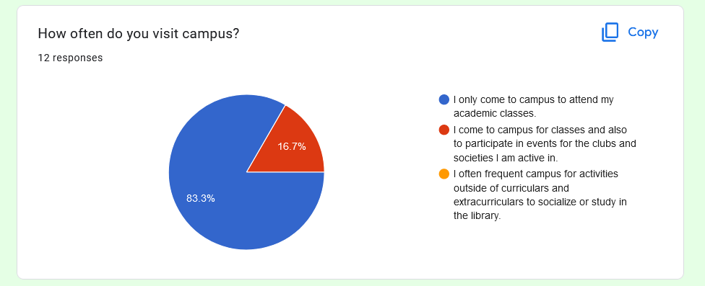

Figure 1.2.4c - Responses Screenshot - Section A (3/3)

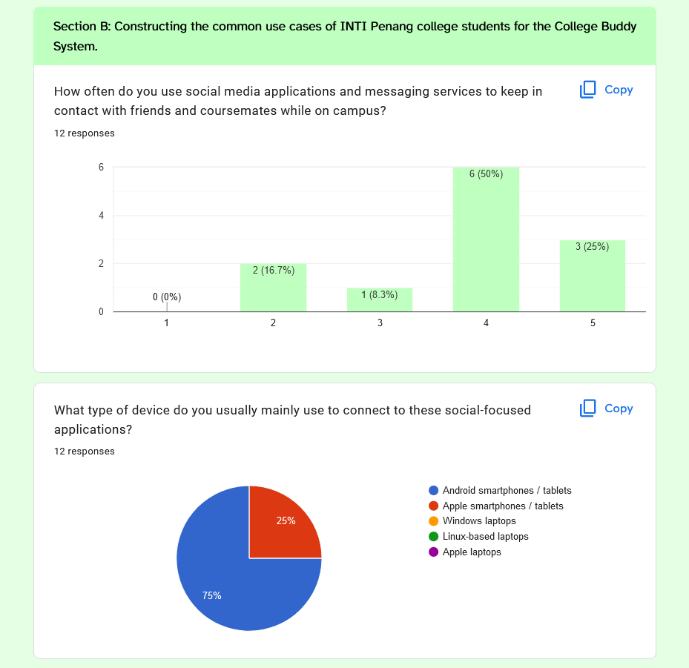

Figure 1.2.5a - Responses Screenshot - Section B - Q1, Q2 (1/6)

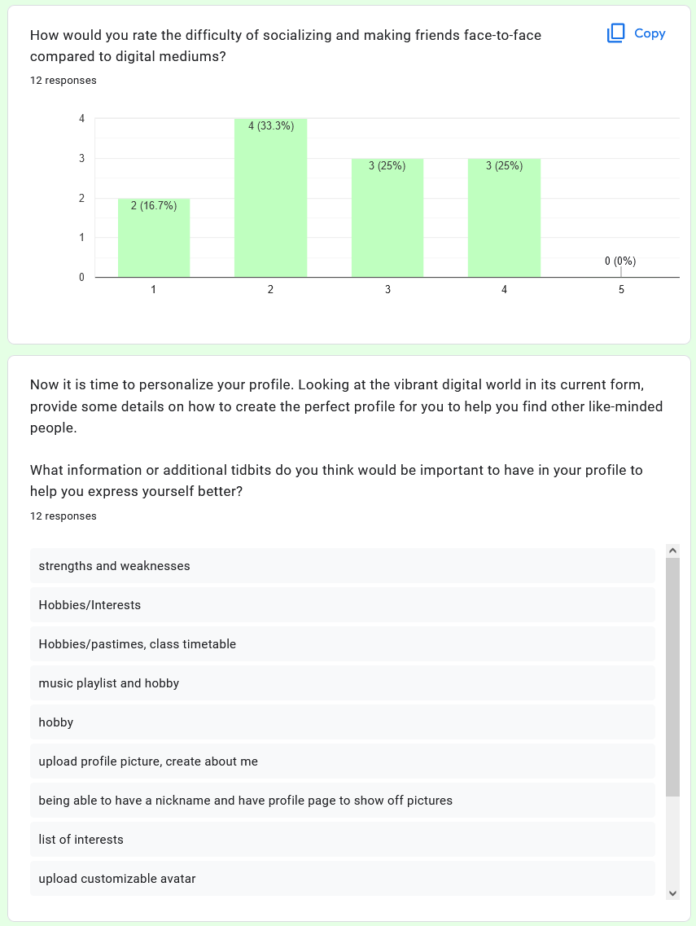

Figure 1.2.5b - Responses Screenshot - Section B – Q3, Q4 (2/6)

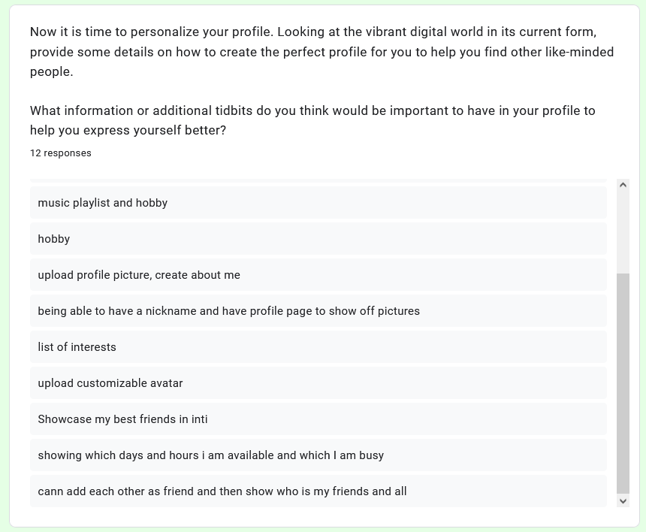

Figure 1.2.5b - Responses Screenshot - Section B – Q4 (cont’d) (3/6)

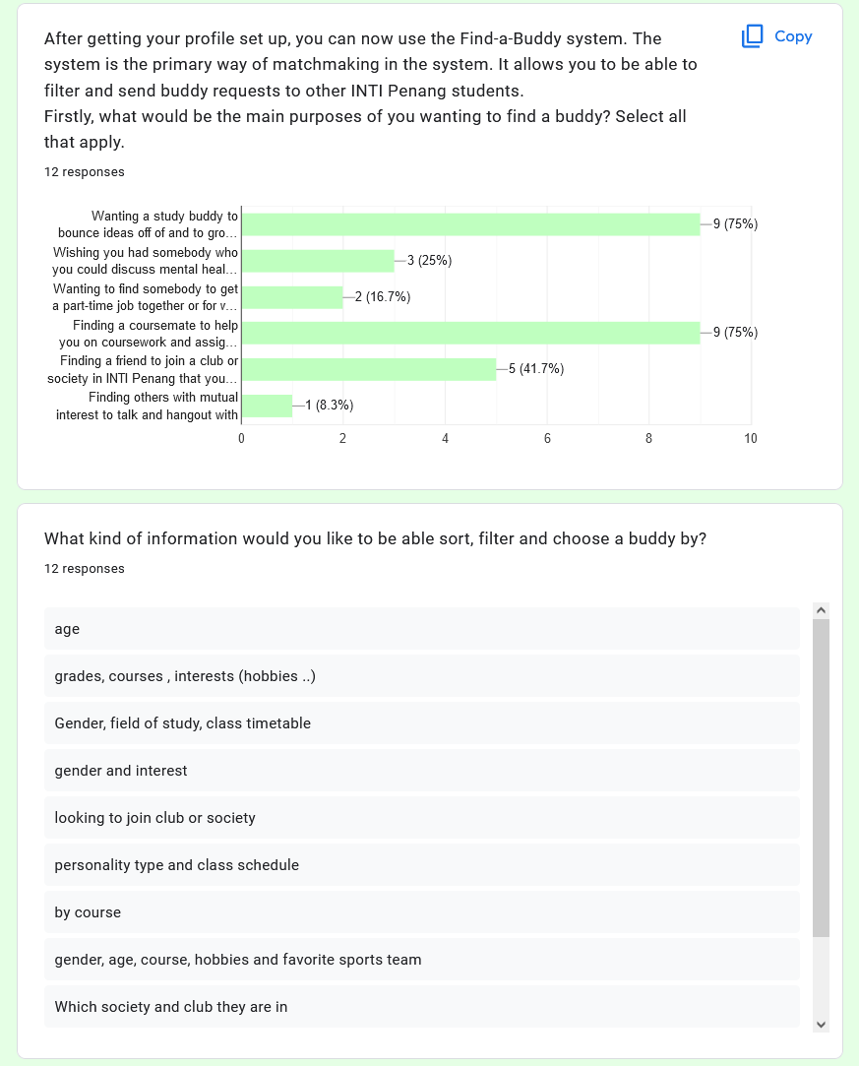

Figure 1.2.5c - Responses Screenshot - Section B – Q5, Q6 (4/6)

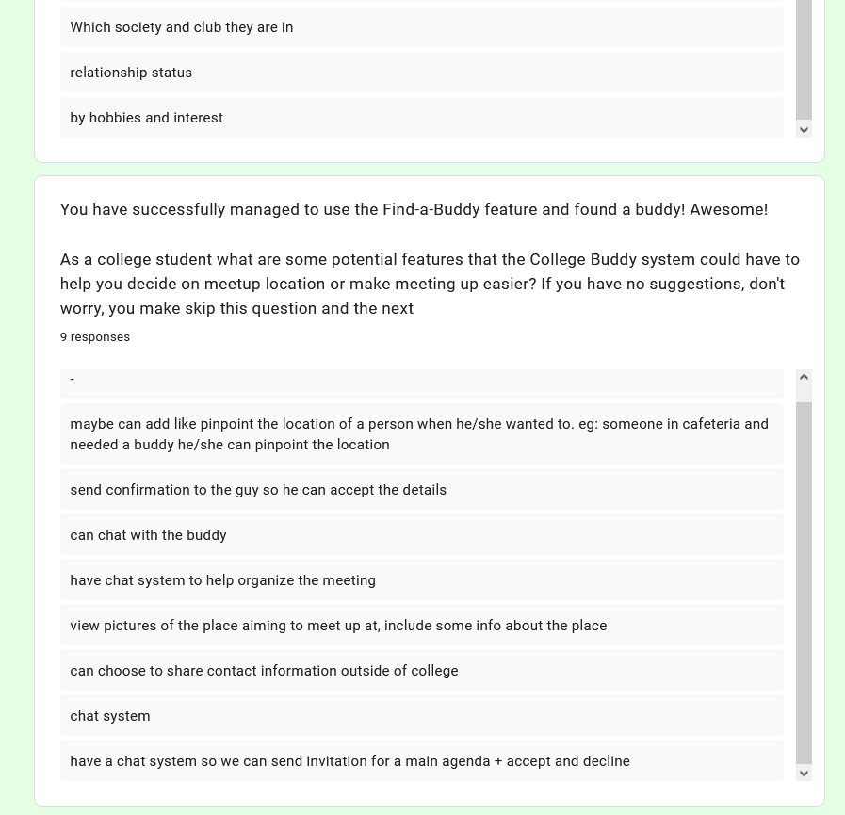

Figure 1.2.5c - Responses Screenshot - Section B – Q6 (cont’d) (5/6)

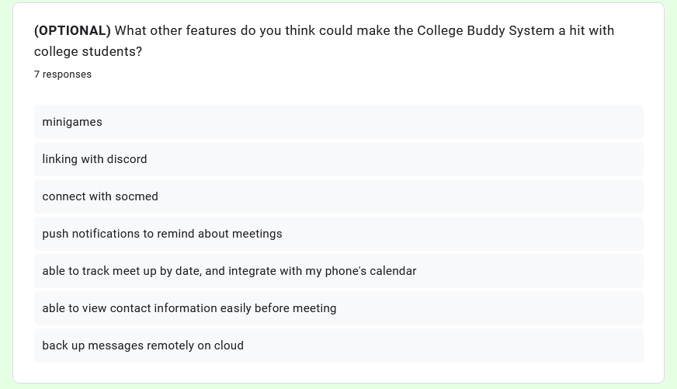

Figure 1.2.5d - Responses Screenshot - Section B – Q7 (cont’d) (6/6)

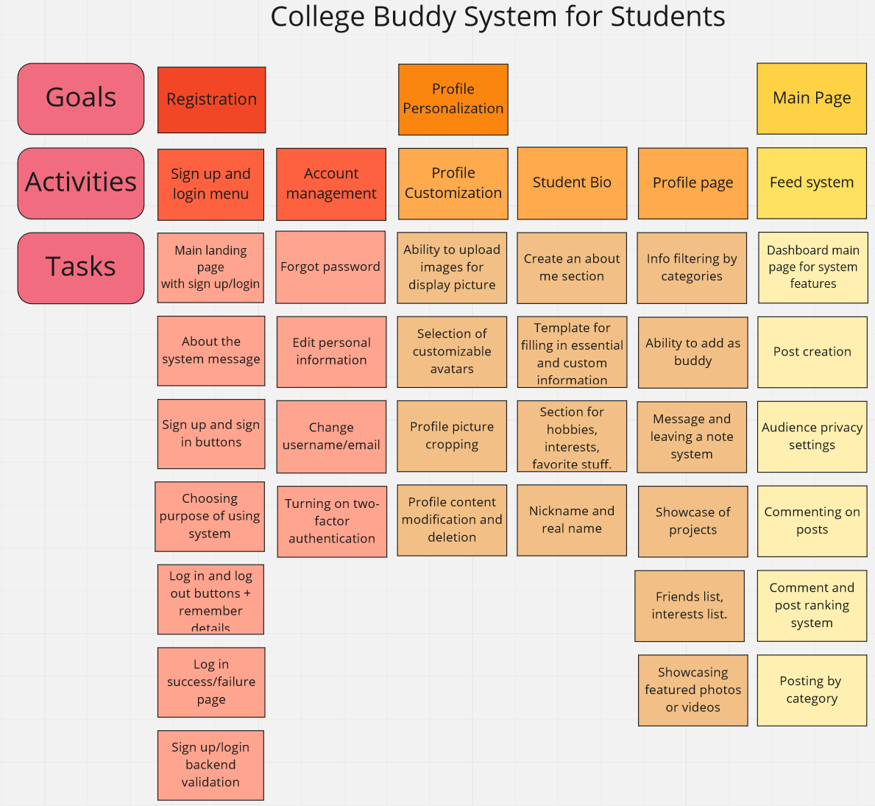

Figure 1.2.6a – Product Backlog for College Buddy System – (1/3)

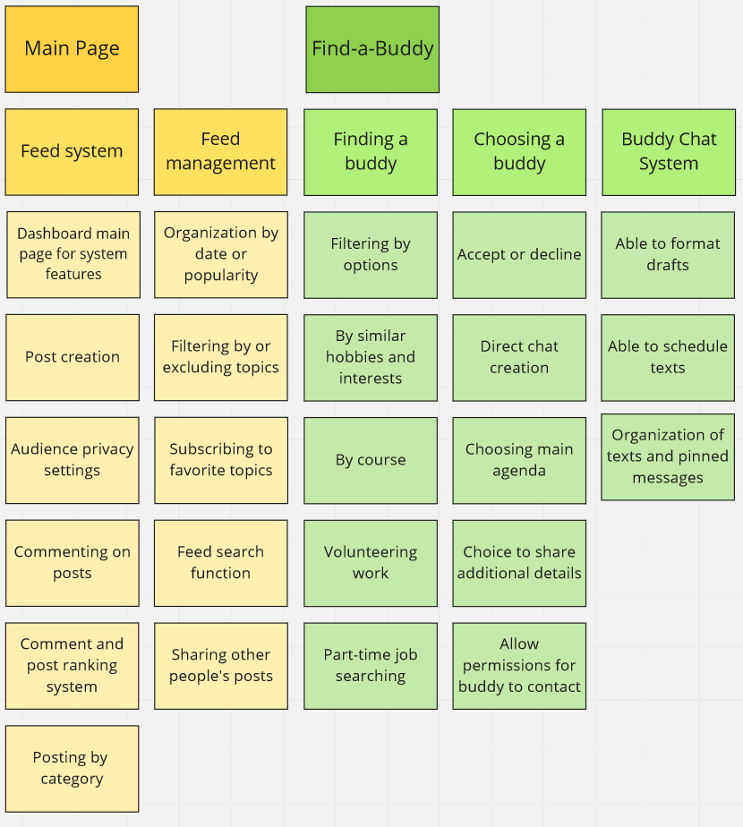

Figure 1.2.6b – Product Backlog for College Buddy System – (2/3)

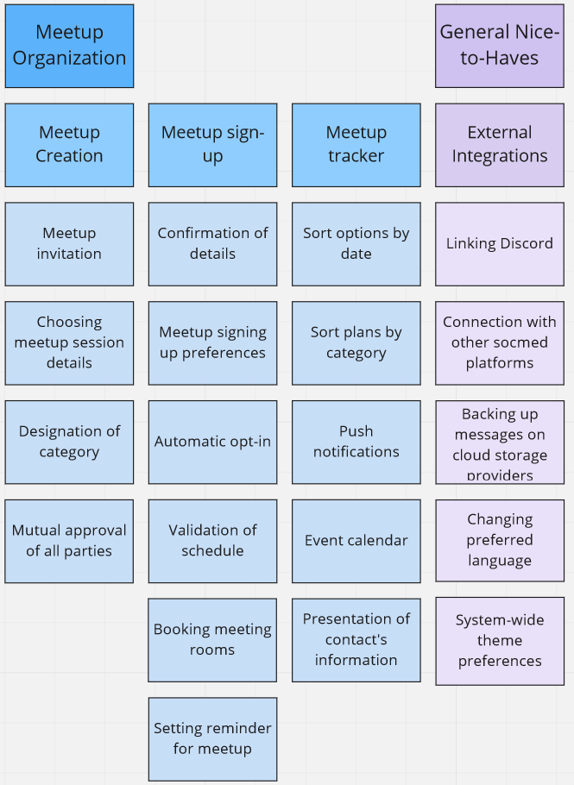

Figure 1.2.6c – Product Backlog for College Buddy System – (3/3)

# 1.3 – SUMMARY, ANALYSIS & REFLECTIONS

Overall, the process of visualizing and organizing work is fundamental to help understand the sets of feasible high-importance features to be created in the software development life cycle of the College Buddy System for Students. The creation of a product backlog aims to satisfy this process. The identifications of omissions in the original backlog made from collected user stories were carried out. This allows the fitting in of additional system components that will ultimately fully round out a robust system. The product backlog manages to pave the way for effective planning in terms of scheduling releases of valuable iterations.

In terms of analysis of the collected results, the questionnaire successfully let us profile the average archetype of a user, that is, in their goals, motivations and representative personal characteristics. After analysis, personas were able to be created. These personas consist of students the age of 20-22 years old, undergraduate students who seek to mainly find a friend to study with or acquire coursework and assignment help from.

In hindsight, a glaring improvement for this task is to incorporate more questions regarding specifications for the registration and login systems and main page. However commonly in software design, we often have to teeter on the balance of technical-completeness with ease of understanding by the user. In terms of target audience, college students are largely dispersed in their software technical know-how. Thus, it is important to take a few key lessons from the execution of the collection of data, including researching our market beforehand.



**Marking Rubric for Continuous Assessment**

|  |  |  |  |  |  |
| --- | --- | --- | --- | --- | --- |
|  | **Marks Below 40%** | **Marks in the range 40 – 49%** | **Marks in the range**  **50 – 59%** | **Marks in the range 60 – 69%** | **Marks 70% and above** |
| **User Story**  **Mapping**  **(20 marks)** | User Story Mapping not done or User Story copied/does not match the exact system. | User Story Mapping done at a minimum level and does not capture the important activities of the system. | User Story Mapping done and does capture several important activities of the system. The breakdown of the user story mapping can be improved. | User Story Mapping done and does capture several important activities of the system. The breakdown of the user story mapping is good and uses software that can assist that process (For example Miro compared to Ms. Word). | User Story Mapping done and does capture most important activities of the system. The breakdown of the  user story mapping is excellent and uses  software that can assist that process (For example Miro  compared to Ms.  Word). |
| **Setting up a**  **GitHub**  **Repository**  **(10 marks)** | GitHub repository does not exist or cannot be accessed or the required files are not available at the time of access. | GitHub repository exist and some of the required files are not available at the time of access. | GitHub repository exist and most of the required files are available at the time of access. However the dates does not follow the required deadline. | GitHub repository exist and all of the required files are available at the time of access. However the dates for some files does not follow the required deadline. | GitHub repository exist and all of the required files are available at the time of access. The dates on the files follows the required deadline. |
| **Creating a Class diagram and design pattern selection**  **(30 marks)** | The Class diagram does not represent the required solution (contains generic or non- related classes such as admin), the design pattern suggested is not suitable for the given problem. | The Class diagram and design pattern represent the required solution but in a very general and incomplete way. Required classes in the design are not declared. | The Class diagram and design pattern represent the required solution in a partial way. A few required classes in the design are not declared. | The Class diagram and design pattern represent the required solution in a satisfactory way. Most required classes are declared. | The Class diagram and design pattern represent the required solution in an excellent way. All required classes are declared. |
| **Creating a**  **Prototype User**  **Interface and**  **Usability Testing**  **(20 marks)** | No prototype were available or the measurement for the usability testing is not clear. | The prototype cover minimalist and trivial design (such as login) and the measurements for the usability testing are not clear. | The prototype cover adequate design and several measurements for the usability testing are not clear. | The prototype cover good design and most measurements for the usability testing are clear. | The prototype cover excellent design and all measurements for the usability testing are clear. |
| **Discuss the**  **ethical issue**  **related to the**  **software**  **(20 marks)** | There is no discussion on the ethical issue or only the theories are pasted back for this component. | There is an attempt to discuss on the ethical issue but no critical  analysis was done | There is an attempt to discuss on the ethical issue with some critical  analysis was done | There is an attempt to discuss on the ethical issue with good critical analysis. | There is an attempt to discuss on the ethical issue with excellent critical analysis. |